**Page 16 #s 2, 3**

2. Categorical Variable

3. Quantitative Variable

**Page 75 #30 (a-d)**



**\*Unimodal is acceptable as well.**

**Page 129 #8**

8. A z-score of -1.88 means that the boy’s height was 1.88 standard deviations below the mean.

**Page 130 #s 11, 20 (a,b)**







**Page 131 # 29(d)**

29(d) Approximately 16% of the trees are expected to have diameters over 15 inches.

**Page 136 #6(b)**

6(b) The mean number of loaves sold will be higher than the median number of loaves sold, since the distribution of sales is skewed to the right

**Page 137 #s 8(a, c, e)**

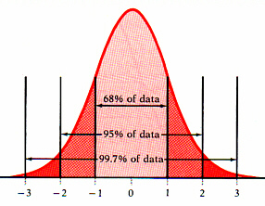8(a)

3.1 3.7 4.3 4.9 5.5 6.1 6.7

8(c) 6.68% of rainstorms are expected to produce rainfall with pH levels below 4.

8(e) The least acidic 5% of storms have pH above 5.89

**Page 141 #28**

**Page 143 #38(a)**

38(a) The five number summary of the profits as a percent of sales of 29 of the *Forbesi* 500 largest US corporation is: -9, 1, 4, 9.5, 25.